So how do we measure density?

The first parameter we use is Eps or Epselon.

It is defined as mentioned in image below.

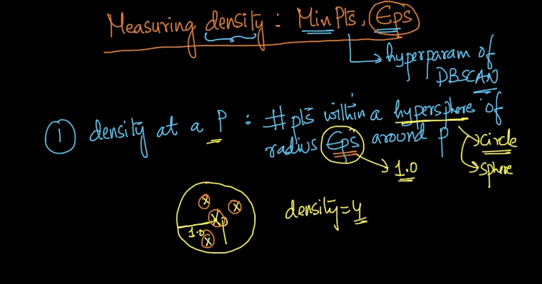

And how we define dense region or sparse region is defined in image below.

i.e. we give some number of point within radius as eps and if number of point within that radius exceeds than we call it dense or else Sparse.

